Database Architecture

* Old Database Architectures → M*ainframe*

• Todays Database Architectures → C*lient-Server*

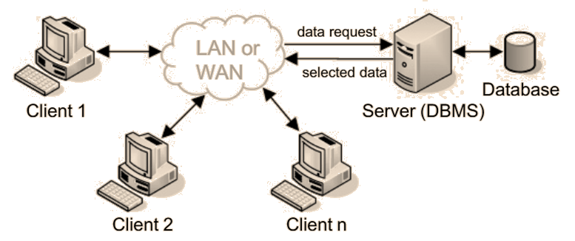

**Some Concepts**

Client

:

Client

is

a

computer

that

send

a

request

to

server

to

receive

data

or

services

.

Server

:

Server

is

a

computer

that

responses

to

clients

for

wanted

data

or

services

by

clients

.

LAN

:

L

ocal

A

rea

N

etwork

WAN

:

W

ide

A

rea

N

etwork

or

Internet

Why used databases?

* 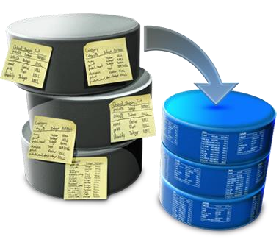Easy to search data.
* Manage information in database.
* Save space.
* Easy to make maintenance.

Entity-Relationship (E-R) Data Model

|  |
| --- |
| Entity |

* **Entity-Relationship (E-R) data model** is the common technique used in database design. It captures the relationships between database tables and represent them in a graphical way. The relationships between two entities can be 1:1, 1:N, or M:N.
* **Entity:** Entity expresses a real-world thing or a concept. For example; an employee or a project which describes in mini-world, in a database.
* **Attribute**: Attribute is the property that defines an entity. For example; employee name or fee.

Attribute

Relationship

* **Relationship**: Relationship expresses the common point and unification between two entity. For example; relating an employee with a project.

# Relational Data Model

**Name**

**Student_ID**

**Class**

**Dept**

Mehmet

17

1

IE

Ayşe

5

2

IE

STUDENT

Table

Attributes

Fields

,

Columns

Records

Entity

Relational Database Model

Relational model is a collection of relations on a database.

**SQL:** Structural Query Language SQL-based DBMSs:

* MS SQL Server
* Oracle
* PostrgreSQL
* MySQL
* Sybase SQL Server
* Informix
* …

Primary Key & Foreign Key

* **Primary Key:** Primary key is a unique field in a table for each record. It provides to separate the records from each other.

**Note:** The data defined in primary key field must not be same to each other!

* **Foreign**the records**Key,**of**Secondary**other tables**Key,**. **Index:** Foreign key is a field to relate **#**

Relational Database Design Rules (I)

* We will create a miniworld virtually! *Each of assets (persons, objects, processes) in the real world can be defined as an entity (table) in the database of virtual miniworld.*



Relational Database Design Rules (II)

* Our aim is to create a database that is efficient and consumes minimal space of data area.



* So **any data** should not repeat itself in the miniworld! (excluse primary keys)
* In a table, the related fields with the other tables can be represented by selected from their primary key (index) fields.
* Representation by primary keys provide using dataspace efficiently.

A Relational Database Design Example:

eMarketing Database

* **Problem:** A database design for a company that sells its products on

Internet.

* First, we define entities in the database.
* **Products;** Barcode, ProductName, TradeMark, Properties, TaxRate, PurchasePrice, SalePrice, Quantity
* **Customers;** CustomerID, FirstName, LastName, eMail, Password, Adress, City, Tel
* **Orders;** OrderID, CustomerID, ProductID, OrderDate, OrderStatus, OrderQuantity

# E-R Diagram of eMarketing Database

Products

Barcode

ProductName

Trademark

Properties

TaxRate

Purchase

Price

SalePrice

Quantity

Customers

CustomerID

FirstName

LastName

Email

Password

Address

City

Tel

Orders

OrderID

CustomerID

ProductBarcode

OrderDate

OrderStatus

OrderQuantity



Sales

N

1

M

**Primary**

**Key**

**#**

**Foreign**

**Key**



**#**

**#**

customer

1

can order

N products

M times

.

Internal Structure of eMarketing Database

Products

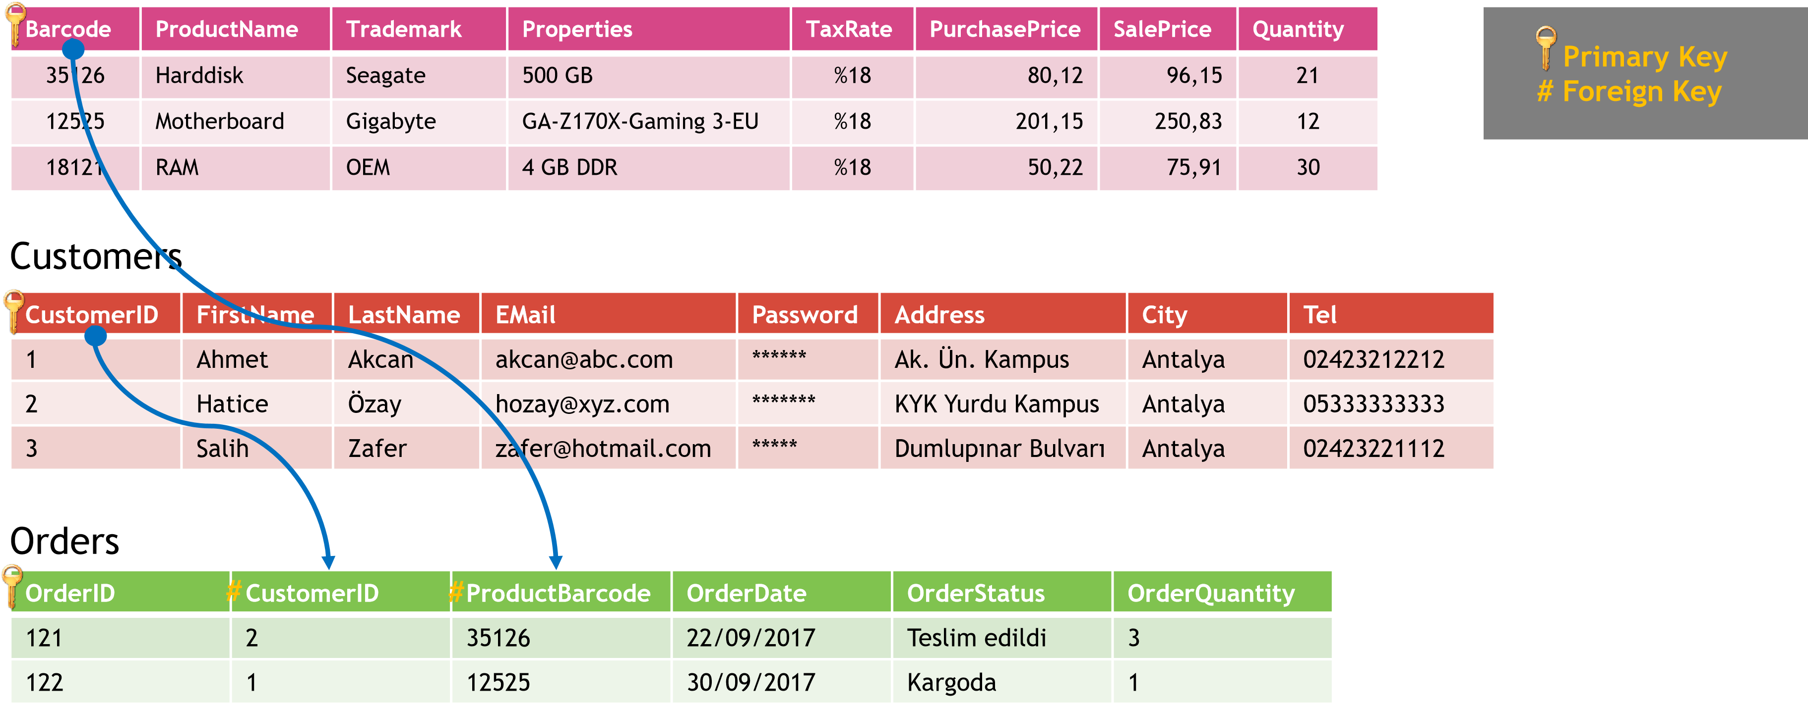

Design of a Database - Mistakes

**Products**

ProductName

Trademark

Properties

Quantity

CustomerName

Address

City

SalePrice

OrderDate

**Products**

Barcode

ProductName

Properties

Quantity

**Customers**

CustomerID

CustomerName

Address

City

**Orders**

OrderID

ProductBarcode

CustomerID

SalePrice

OrderDate

**WRONG! RIGHT!**

## Design of a Database – Mistakes

**Products**

Barcode

ProductName

Properties

Quantity

OrderID

**Customers**

CustomerID

CustomerName

Address

City

ProductID

**Orders**

OrderID

ProductBarcode

CustomerID

SalePrice

OrderDate

**WRONG!**

**WRONG!**

If

designed

as

above

,

a

product

can be

sell

only

one

time!!!

If

designed

as

above

,

a

customer

can

order

only

one

time!!!

E-R Diagram for the UNIVERSITY Database

Student

Name

StudentID

Class

Department

Precondition

CourseID

PreconditionID

Semester

Course

SemesterID

CourseID

Lecturer

Semester

Year

CourseName

CourseID

Credit

Department

Opening

courses

Selecting

courses

1

N

M

1

N

Grades

StudentID

SemesterID

Grade

Evaluation

1

N

N

determines

N

1



**#**

**#**

**#**

**#**

**#**

**Primary**

**Key**

**#**

**Foreign**

**Key**



## Database Schema Diagram

• Schema diagrams are the shapes that show entities, attributes and relationships in a database.

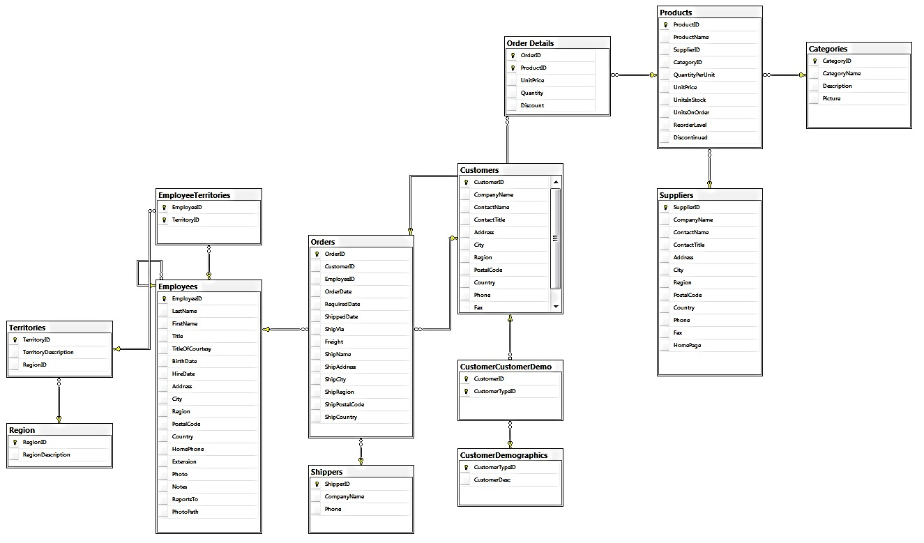

## Three-Layer Architecture

•

It

defines

internal

structure

of a

database

.

Internal

Layer

•

It

is

defines

the

data model of

database

.

It

also

provide

the

with

connection

user

and

internal

layer

.

Conceptual

Layer

•

It

is a

user

-

friendly

interface

of

database

.

External

Layer

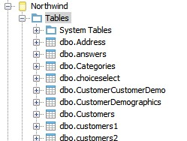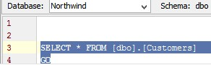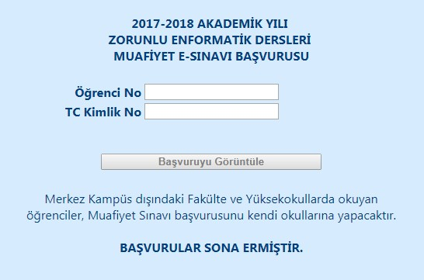

## Database Design Problems

* A database for a library to perform borrowing/lending of books process.
* A database for a pharmacy to sell medicines.
* A database for a bus company to sell ticket.